Lab – Troubleshooting Basic PPP with Authentication

1. Topology

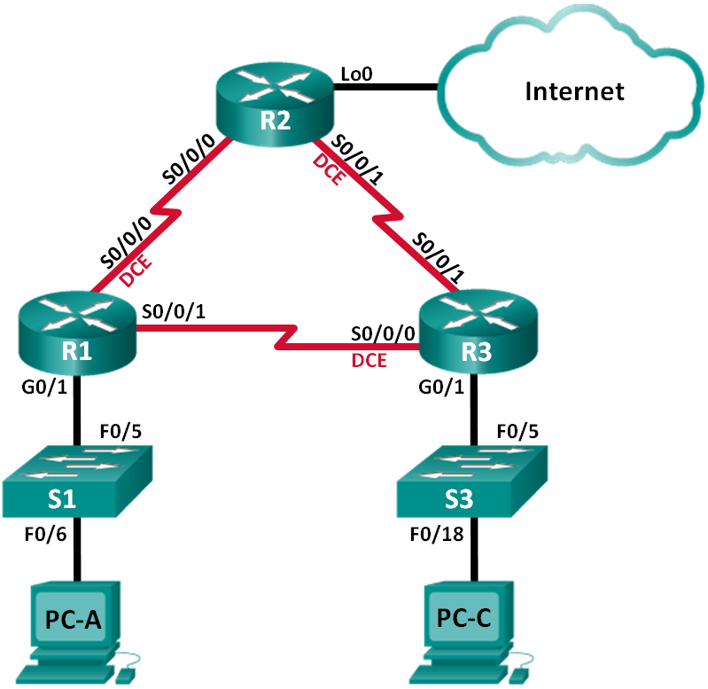

1. Addressing Table

|  |  |  |  |  |
| --- | --- | --- | --- | --- |
| Device | Interface | IP Address | Subnet Mask | Default Gateway |
| R1 | G0/1 | 192.168.1.1 | 255.255.255.0 | N/A |
|  | S0/0/0 (DCE) | 192.168.12.1 | 255.255.255.252 | N/A |
|  | S0/0/1 | 192.168.13.1 | 255.255.255.252 | N/A |
| R2 | Lo0 | 209.165.200.225 | 255.255.255.252 | N/A |
|  | S0/0/0 | 192.168.12.2 | 255.255.255.252 | N/A |
|  | S0/0/1 (DCE) | 192.168.23.1 | 255.255.255.252 | N/A |
| R3 | G0/1 | 192.168.3.1 | 255.255.255.0 | N/A |
|  | S0/0/0 (DCE) | 192.168.13.2 | 255.255.255.252 | N/A |
|  | S0/0/1 | 192.168.23.2 | 255.255.255.252 | N/A |
| PC-A | NIC | 192.168.1.3 | 255.255.255.0 | 192.168.1.1 |
| PC-C | NIC | 192.168.3.3 | 255.255.255.0 | 192.168.3.1 |

Objectives

Part 1: Build the Network and Load Device Configurations

Part 2: Troubleshoot the Data Link Layer

Part 3: Troubleshoot the Network Layer

1. Background / Scenario

The routers at your company were configured by an inexperienced network engineer. Several errors in the configuration have resulted in connectivity issues. Your manager has asked you to troubleshoot and correct the configuration errors and document your work. Using your knowledge of PPP and standard testing methods, find and correct the errors. Ensure that all of the serial links use PPP CHAP authentication, and that all of the networks are reachable.

**Note**: The routers used with CCNA hands-on labs are Cisco 1941 Integrated Services Routers (ISRs) with Cisco IOS Release 15.2(4)M3 (universalk9 image). The switches used are Cisco Catalyst 2960s with Cisco IOS Release 15.0(2) (lanbasek9 image). Other routers, switches, and Cisco IOS versions can be used. Depending on the model and Cisco IOS version, the commands available and output produced might vary from what is shown in the labs. Refer to the Router Interface Summary Table at the end of this lab for the correct interface identifiers.

**Note**: Make sure that the routers and switches have been erased and have no startup configurations. If you are unsure, contact your instructor.

1. Required Resources

* 3 Routers (Cisco 1941 with Cisco IOS Release 15.2(4)M3 universal image or comparable)
* 2 Switches (Cisco 2960 with Cisco IOS Release 15.0(2) lanbasek9 image or comparable)
* 2 PCs (Windows 7, Vista, or XP with a terminal emulation program, such as Tera Term)
* Console cables to configure the Cisco IOS devices via the console ports
* Ethernet and serial cables as shown in the topology

1. Build the Network and Load Device Configurations

In Part 1, you will set up the network topology, configure basic settings on the PC hosts, and load configurations on the routers.

* 1. Cable the network as shown in the topology.
  2. Configure the PC hosts.
  3. Load router configurations.

Load the following configurations into the appropriate router. All routers have the same passwords. The privileged EXEC mode password is **class**. The password for console and vty access is **cisco**. All serial interfaces should be configured with PPP encapsulation and authenticated with CHAP using the password of **chap123**.

Router R1 Configuration:

hostname R1

enable secret class

no ip domain lookup

banner motd #Unauthorized Access is Prohibited!#

username R2 password chap123

username R3 password chap123

interface g0/1

ip address 192.168.1.1 255.255.255.0

no shutdown

interface s0/0/0

ip address 192.168.12.1 255.255.255.252

clock rate 128000

encapsulation ppp

ppp authentication chap

interface s0/0/1

ip address 192.168.31.1 255.255.255.252

encapsulation ppp

ppp authentication pap

exit

router ospf 1

router-id 1.1.1.1

network 192.168.1.0 0.0.0.255 area 0

network 192.168.12.0 0.0.0.3 area 0

network 192.168.13.0 0.0.0.3 area 0

passive-interface g0/1

exit

line con 0

password cisco

logging synchronous

login

line vty 0 4

password cisco

login

Router R2 Configuration:

hostname R2

enable secret class

no ip domain lookup

banner motd #Unauthorized Access is Prohibited!#

username R1 password chap123

username r3 password chap123

interface lo0

ip address 209.165.200.225 255.255.255.252

interface s0/0/0

ip address 192.168.12.2 255.255.255.252

encapsulation ppp

ppp authentication chap

no shutdown

interface s0/0/1

ip address 192.168.23.1 255.255.255.252

clock rate 128000

no shutdown

exit

router ospf 1

router-id 2.2.2.2

network 192.168.12.0 0.0.0.3 area 0

network 192.168.23.0 0.0.0.3 area 0

default-information originate

exit

ip route 0.0.0.0 0.0.0.0 loopback0

line con 0

password cisco

logging synchronous

login

line vty 0 4

password cisco

login

Router R3 Configuration:

hostname R3

enable secret class

no ip domain lookup

banner motd #Unauthorized Access is Prohibited!#

username R2 password chap123

username R3 password chap123

interface g0/1

ip address 192.168.3.1 255.255.255.0

no shutdown

interface s0/0/0

ip address 192.168.13.2 255.255.255.252

clock rate 128000

encapsulation ppp

ppp authentication chap

no shutdown

interface s0/0/1

ip address 192.168.23.2 255.255.255.252

encapsulation ppp

ppp authentication chap

no shutdown

exit

router ospf 1

router-id 3.3.3.3

network 192.168.13.0 0.0.0.3 area 0

network 192.168.23.0 0.0.0.3 area 0

passive-interface g0/1

line con 0

password cisco

logging synchronous

login

line vty 0 4

password cisco

login

* 1. Save your running configuration.

1. Troubleshoot the Data Link Layer

In Part 2, you will use **show** commands to troubleshoot data link layer issues. Be sure to verify settings, such as clock rate, encapsulation, CHAP, and usernames/passwords.

* 1. Examine the R1 configuration.
     1. Use the **show interfaces** command to determine whether PPP has been established on both serial links.

From the **show interfaces** results for S0/0/0 and S0/0/1, what are possible issues with the PPP links?

____________________________________________________________________________________

____________________________________________________________________________________

____________________________________________________________________________________

* + 1. Use the **debug ppp authentication** command to view real-time PPP authentication output during troubleshooting.

R1# **debug ppp authentication**

PPP authentication debugging is on

* + 1. Use the **show run interface s0/0/0** command to examine the settings on S0/0/0.

Resolve all problems found for S0/0/0. Record the commands used to correct the configuration.

____________________________________________________________________________________

____________________________________________________________________________________

After correcting the issue, what information does the debug output provide?

____________________________________________________________________________________

____________________________________________________________________________________

* + 1. Use the **show run interface s0/0/1** command to examine the settings on S0/0/1.

Resolve all problems found for S0/0/1. Record the commands used to correct the configuration.

____________________________________________________________________________________

____________________________________________________________________________________

____________________________________________________________________________________

After correcting the issue, what information does the debug output provide?

____________________________________________________________________________________

____________________________________________________________________________________

* + 1. Use the **no debug ppp authentication** or **undebug all** command to turn off the debug PPP output.
    2. Use the **show running-config | include username** command to verify the correct username and password configurations.

Resolve all problems found. Record the commands used to correct the configuration.

____________________________________________________________________________________

* 1. Examine the R2 configuration.
     1. Use the **show interfaces** command to determine if PPP has been established on both serial links.

Have all links been established? ______________

If the answer is no, which links need to be examined? What are the possible issues?

____________________________________________________________________________________

____________________________________________________________________________________

____________________________________________________________________________________

* + 1. Use the **show run interface** command to examine links that have not been established.

Resolve all problems found for the interfaces. Record the commands used to correct the configuration.

____________________________________________________________________________________

____________________________________________________________________________________

____________________________________________________________________________________

* + 1. Use the **show running-config | include username** command to verify the correct username and password configurations.

Resolve all problems found. Record the commands used to correct the configuration.

____________________________________________________________________________________

____________________________________________________________________________________

* + 1. Use the **show ppp interface serial** command for the serial interface that you are troubleshooting.

Has the link been established? ______________

* 1. Examine the R3 configuration.
     1. Use the **show interfaces** command to determine whether PPP has been established on both serial links.

Have all links been established? ______________

If the answer is no, which links need to be examined? What are the possible issues?

____________________________________________________________________________________

____________________________________________________________________________________

* + 1. Using the **show run interface** command to examine on any serial link that has not been established.

Resolve all problems found on the interfaces. Record the commands used to correct the configuration.

____________________________________________________________________________________

* + 1. Use the **show running-config | include username** command to verify the correct username and password configurations.

Resolve all problems found. Record the commands used to correct the configuration.

____________________________________________________________________________________

____________________________________________________________________________________

* + 1. Use the **show interface** command to verify that serial links have been established.
    2. Have all PPP links been established? ______________
    3. Can PC-A ping Lo0? ______________
    4. Can PC-A ping PC-C? ______________

**Note**: It may be necessary to disable the PC firewall for pings between the PCs to succeed.

1. Troubleshoot the Network Layer

In Part 3, you will verify that Layer 3 connectivity is established on all interfaces by examining IPv4 and OSPF configurations.

* 1. Verify that the interfaces listed in the Addressing Table are active and configured with the correct IP address information.

Issue the **show ip interface brief** command on all routers to verify that the interfaces are in an up/up state.

Resolve all problems found. Record the commands used to correct the configuration.

____________________________________________________________________________________

____________________________________________________________________________________

* 1. Verify OSPF Routing

Issue the **show ip protocols** command to verify that OSPF is running and that all networks are advertised.

Resolve all problems found. Record the commands used to correct the configuration.

____________________________________________________________________________________

____________________________________________________________________________________

Can PC-A ping PC-C? ______________

If connectivity does not exist between all hosts, then continue troubleshooting to resolve any remaining issues.

**Note**: It may be necessary to disable the PC firewall for pings between the PCs to succeed.

1. Router Interface Summary Table

|  |  |  |  |  |
| --- | --- | --- | --- | --- |
| Router Interface Summary | | | | |
| Router Model | Ethernet Interface #1 | Ethernet Interface #2 | Serial Interface #1 | Serial Interface #2 |
| 1800 | Fast Ethernet 0/0 (F0/0) | Fast Ethernet 0/1 (F0/1) | Serial 0/0/0 (S0/0/0) | Serial 0/0/1 (S0/0/1) |
| 1900 | Gigabit Ethernet 0/0 (G0/0) | Gigabit Ethernet 0/1 (G0/1) | Serial 0/0/0 (S0/0/0) | Serial 0/0/1 (S0/0/1) |
| 2801 | Fast Ethernet 0/0 (F0/0) | Fast Ethernet 0/1 (F0/1) | Serial 0/1/0 (S0/1/0) | Serial 0/1/1 (S0/1/1) |
| 2811 | Fast Ethernet 0/0 (F0/0) | Fast Ethernet 0/1 (F0/1) | Serial 0/0/0 (S0/0/0) | Serial 0/0/1 (S0/0/1) |
| 2900 | Gigabit Ethernet 0/0 (G0/0) | Gigabit Ethernet 0/1 (G0/1) | Serial 0/0/0 (S0/0/0) | Serial 0/0/1 (S0/0/1) |
| **Note**: To find out how the router is configured, look at the interfaces to identify the type of router and how many interfaces the router has. There is no way to effectively list all the combinations of configurations for each router class. This table includes identifiers for the possible combinations of Ethernet and Serial interfaces in the device. The table does not include any other type of interface, even though a specific router may contain one. An example of this might be an ISDN BRI interface. The string in parenthesis is the legal abbreviation that can be used in Cisco IOS commands to represent the interface. | | | | |